DATA SCIENCE INTERNSHIP
Task 3 Report
Exploratory Data Analysis (EDA)
Prepared for: Decodelabs Internship Submission
Dataset: Online-Store-Orders.xlsx (1,200 real order records)
Tools: Python, pandas, NumPy, Matplotlib

1. Objective
Analyze the cleaned dataset to discover patterns and trends: calculate basic statistics, identify trends and outliers, and summarize findings.

2. Headline Metrics
Metric | Value
Total Revenue (all orders) | $1,264,761.96
Realized Revenue (Delivered + Shipped) | $488,759.90
Total Orders | 1,200
Average Order Value | $1,053.97
Unique Customers | 1,189
Cancelled + Returned Rate | 41.4%
Outlier Orders (IQR method) | 8 (0.7%)

3. Revenue by Product
Chair and Printer lead in total revenue, both slightly ahead of Laptop and Tablet, with Phone generating the least revenue despite likely higher order volume — reflecting its lower unit price.
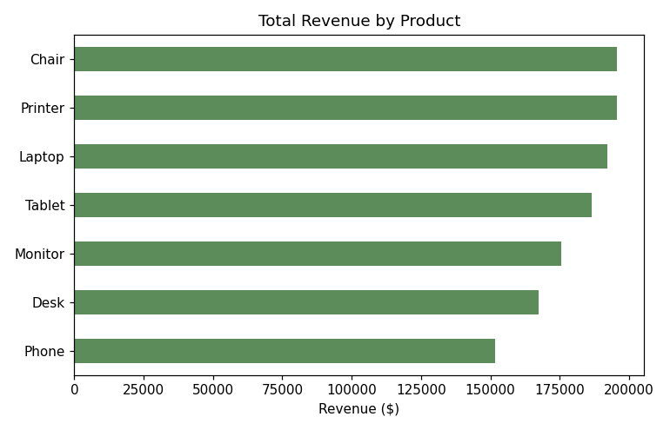

4. Monthly Revenue Trend
Revenue fluctuates month to month without a clear seasonal pattern, ranging roughly from $28K to $68K per month across the 2.5-year window, with no sustained upward or downward trajectory.
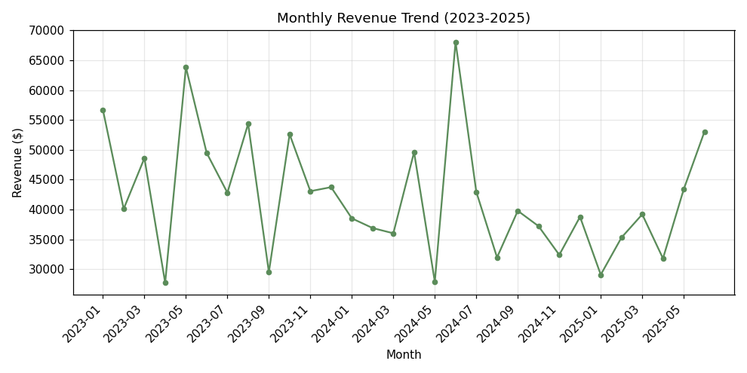

5. Order Status Breakdown
Orders are spread almost evenly across the five statuses. Notably, Cancelled (250) and Returned (247) orders together make up 41.4% of all orders — a significant share that merits operational attention (e.g. reviewing product quality, fulfillment accuracy, or checkout friction).
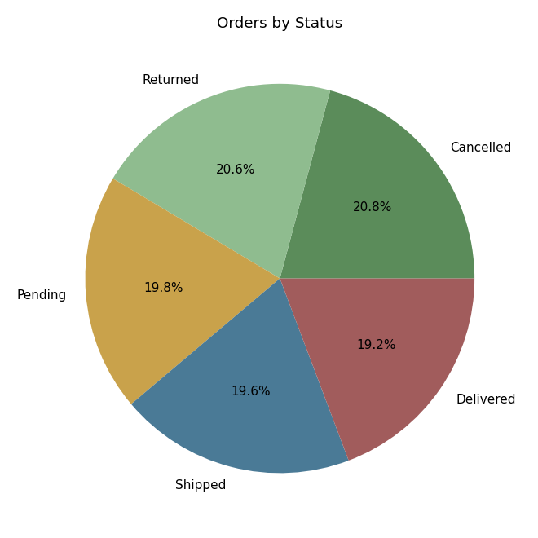

6. Order Value Distribution
Order values range from about $11 to $3,456 and are right-skewed, with most orders under $1,600 and a small tail of high-value orders — only 8 orders (0.7%) are statistical outliers by the IQR method, indicating very few extreme cases.
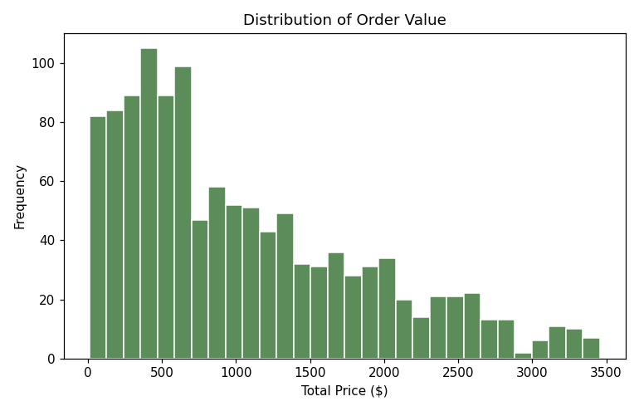

7. Revenue by Payment Method & Product
Credit Card narrowly leads in total revenue ($263,848), followed closely by Online, Cash, Gift Card, and Debit Card — payment method preference is fairly balanced and does not skew heavily toward any one channel.
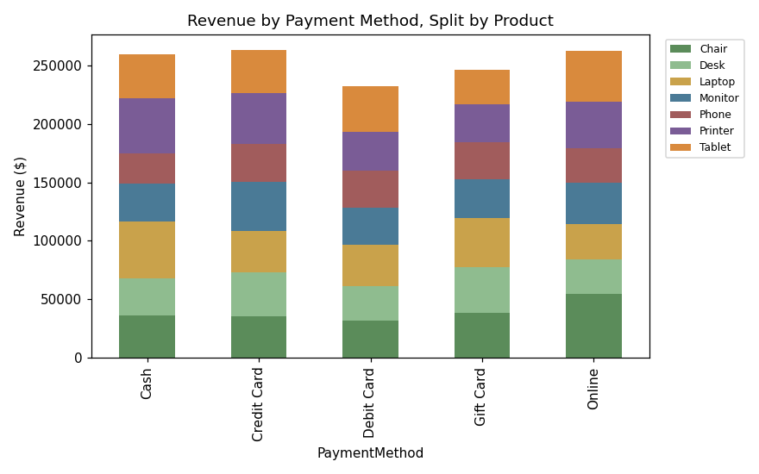

8. Orders by Referral Source
Instagram is the top acquisition channel (259 orders), followed by Email, Google, Facebook, and Referral — all five channels are within a fairly narrow range, suggesting a diversified and balanced marketing mix.
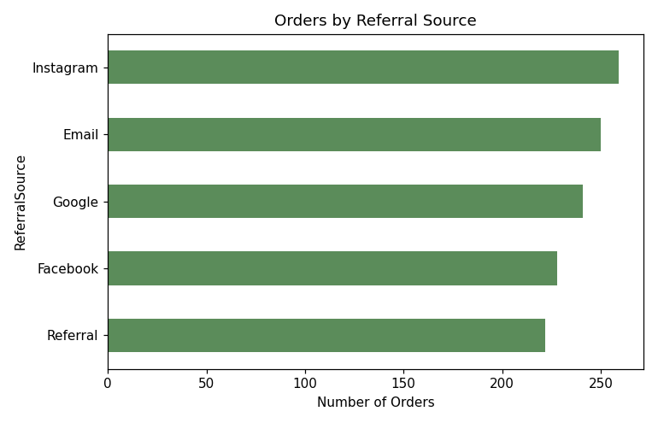

9. Coupon Impact
Orders placed with a coupon average $1,057.64, essentially the same as the $1,043.37 average for orders without one — coupon usage does not appear to meaningfully influence order size in this dataset.

10. Correlation Analysis
TotalPrice correlates most strongly with UnitPrice (r=0.72) and moderately with Quantity (r=0.62), as expected since both feed directly into the total. ItemsInCart shows only a weak relationship with TotalPrice (r=0.39), meaning a larger cart doesn't reliably translate into a larger order.

11. Key Findings
- Chair is the top revenue product ($195,620); Phone is the lowest ($151,722).
- 41.4% of orders are Cancelled or Returned — the single most actionable finding in this dataset.
- Revenue is stable but volatile month-to-month, with no clear seasonal trend over 2.5 years.
- Payment methods and referral sources are both fairly evenly distributed — no single channel dominates.
- Coupons do not meaningfully change average order value ($1,057.64 vs $1,043.37).
- Only 0.7% of orders are statistical outliers by value, indicating a consistent, low-variance pricing pattern outside of a handful of large orders.

12. Code Used
prod_rev = df.groupby("Product")["TotalPrice"].sum()
df["OrderStatus"].isin(["Cancelled","Returned"]).mean()
monthly = df.groupby("OrderMonth").agg(Orders=("OrderID","count"), Revenue=("TotalPrice","sum"))
corr = df[["Quantity","UnitPrice","ItemsInCart","TotalPrice"]].corr()

13. Conclusion
The EDA shows a stable, evenly-distributed sales pattern across products, payment methods, and acquisition channels, with no strong seasonal trend. The standout finding is the 41.4% Cancelled/Returned rate, which is the clearest opportunity area for the business — future work (e.g. Task 5) could build a classification model to predict which orders are at risk of cancellation or return.

